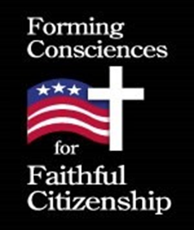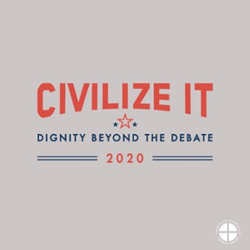

Week 2: Pray, Learn and Act as Faithful Citizens
Intro: The Office of Human Life and Dignity and Catholic Charities- Social Concerns have collaborated to offer you the second of seven weeks of prayer, study and action as we prepare for an upcoming election. Today, we will begin to explore the teaching document from the United States Conference of Catholic Bishops, Forming Consciences for Faithful Citizenship, which “provides guidance for all who seek to exercise their rights and duties as citizens.” This week we will take a brief look at the Introduction to the Bishops’ statement, and we encourage you to visit https://www.usccb.org/issues-and-action/faithful-citizenship/forming-consciences-for-faithful-citizenship-introductory-letter to read the text in its entirety. Recognizing that in all times and places “Jesus Christ is Lord,” (Philippians 2:11) we begin in prayer…
Pray:
Merciful Father,
Thank you for inviting each of us to join in your work
of building the kingdom of love, justice, and peace.
Draw us close to you in prayer
as we discern your call in our families and communities.
Send us forth to encounter all whom you love:
those not yet born, those in poverty, those in need of welcome.
Inspire us to respond to the call to faithful citizenship,
during election season and beyond.
Help us to imitate your charity and compassion
and to serve as models of loving dialogue.
Teach us to treat others with respect, even when we disagree,
and seek to share your love and mercy.
We ask this through Jesus Christ our Lord, who lives and reigns with you in the unity of the Holy Spirit, one God forever and ever. Amen.
-From the Introduction to Forming Consciences for Faithful Citizenship

Learn
“At all levels of society, we are aware of a great need for leadership that models love for righteousness (Wisdom 1:1) as well as the virtues of justice, prudence, courage and temperance. Our commitment as people of faith to imitate Christ’s love and compassion should challenge us to serve as models of civil dialogue, especially in a context where discourse is eroding at all levels of society. Where we live, work, and worship, we strive to understand before seeking to be understood, to treat with respect those with whom we disagree, to dismantle stereotypes, and to build productive conversation in place of vitriol.
Catholics from every walk of life can bring their faith and our consistent moral framework to contribute to important work in our communities, nation, and world on an ongoing basis, not just during election season. In this coming year and beyond, we urge leaders and all Catholics to respond in prayer and action to the call to faithful citizenship. In doing so, we live out the call to holiness and work with Christ as he builds his kingdom of love.”- Forming Consciences for Faithful Citizenship, Introduction
Act:
Register to attend the Indiana Catholic Conference’s upcoming live webinar, “Beyond Secular Politics: Walking in Faithful Citizenship and the ICC” which will be held on October 5th, 7th or 10th. Registration is available at indianacc.org/events. As you do, pray a Memorare with the intention of ensuring that our “participation in political parties and other groups to which we may belong be influenced by our faith, not the other way around.”- Forming Consciences for Faithful Citizenship, Introduction
